By Joe Castro

Linux Hardening Qualifier

# README.txt File for Instructions

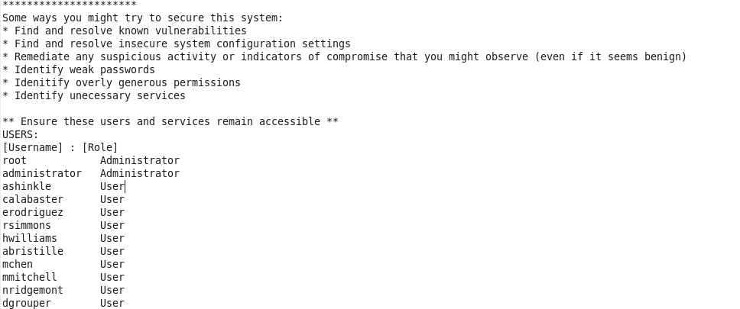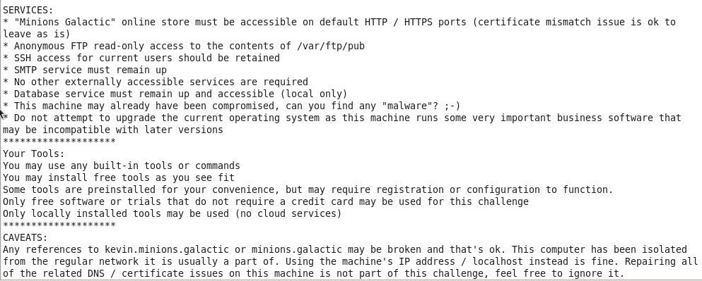

**Notes:**

* Pass.txt in www/html: R4liFfnE
* Do not update system
* Was not able to use machine browser after the first day, probably messed with the config settings

**Documentation:**

I was able to log into root with the same password used for Administrator. So throughout this write-up I will be using the root account.

First, I ensured that cURL, NSS, openssl, and CA certificates are up-to-date by using this command **yum update ca-certificates curl nss openssl.**

The tool we will be using is called **Lynis.** Necessarily what Lynis does is conduct a security scan of our system**.** Install Lynis using command **yum install lynis** and conduct the audit using **lynis audit system –no-colors.** References to the links used to install Lynis are on the References page.

The results from this scan show us a lot of things so I took screenshots of the results and stored them below if you want to see the output of the scan. I’ll go in order of the changes I made to harden the system.

### 1. Run Malware Scanner

First, I installed chkrootkit to search for rootkits or other viruses on the system. The command to install the tool is **yum install chkrootkit** and run the scan by typing **chkrootkit** on the command line. After the scan, it seems like there was no detection of a rootkit or similar malware. Then I conducted another malware scan with Clamav but the installation was outdated.

### 2. Configure Umask to be more Strict

Umask defines what default file permissions will be applied on a file or directory. It is recommended to make the Umask more strict to help limit who can access created files. We can see what the current permissions for umask are currently set to by using **cat /etc/login.defs**,as we can see the current umask permissions are set to 077, it is recommended to have it set at 022. To make this change we enter **sudo nano /etc/login.defs** in the terminalas root because the Administrator account does not have sudo privileges.



### 3. Enable Firewall



### 4. ICMP Filtering on Firewall

The only essential ICMP traffic you need to allow in and out of your firewall is Type 3 (Destination Unreachable) and Type 4 (Source Quench). Everything else is either optional or should be blocked. For this system I will be blocking Type 5 (Redirect) and Type 12 (Parameter Problem). This will all be done through the **Firewall Configuration** application.



### 5. Set PHP expose_php off

The expose_php setting is used to set whether information about the server’s PHP version should be shown to the users or not. If expose_php is set as on, an attacker can see the version of the PHP running on the application’s server. To set this option off we have to write to the **/etc/php.ini** file. Finding the occurrence of the option took a little time since it was buried among 1600 lines. I used **grep** to find the occurrence of **“expose_php”** and then add the **-n** flag to display the line number. To make the changes on the file we use **nano /etc/php.ini** and enter **Alt+C** to show us the line numbers and from here we scroll down to line 432 where **expose_php = On** and we simply replace **On** with **Off**. Then save the changes to the file. Below I will have a short demonstration of each step I just explained.



### 6. SSH Hardening

SSH service is running on this system so we have to make sure that it is hardened. Here is a list of the configurations we will be changing in the **/etc/ssh/sshd_config** file:

1. **AllowTcpForwarding (YES --> NO)**
2. **ClientAliveCountMax (3 --> 2)**
3. **Compression (DELAYED --> NO)**
4. **LogLevel (INFO --> VERBOSE)**
5. **MaxAuthTries (6 --> 2)**
6. **MaxSessions (10 --> 2)**
7. **X11Forwarding (YES --> NO)**
8. **UsePriviledgeSeparation (YES --> SANDBOX)**

Since there are many configuration options to change I’ll be going through step-by-step of only the first configuration we will be making and the rest can be applied the same way with their respective configuration changes.

First, I check to see how many lines there are in the **sshd_config** file. We do this by using **cat /etc/ssh/sshd_config | wc -l**. It shows that there are 138 lines in sshd_config. Use **grep** to find the occurrence of **“AllowTcpForwarding”** and then add the **-n** flag to display the line number. It shows us that the **#AllowTcpForwarding yes** option is commented out on line 106 with the **#** symbol.To make the changes on the file we use **nano /etc/ssh/sshd_config** and enter **Alt+C** to show us the line numbers and from here we scroll down to line 106 where **#AllowTcpForwarding yes** is locatedand we simply replace **yes** with **no** and remove the **#** symbol. Then save the changes to the file. Below I will have a short demonstration of each step I just explained.



Since we saw that the other configuration options are located in the same area where we found **AllowTcpForwarding** the same method is applied to change each configuration but with their respective configuration change which is located in the numbered list above. Ex.**ClientAliveCountMax (3 --> 2)**, now apply each change in the list to harden SSH.

# **Results from Lynis:**

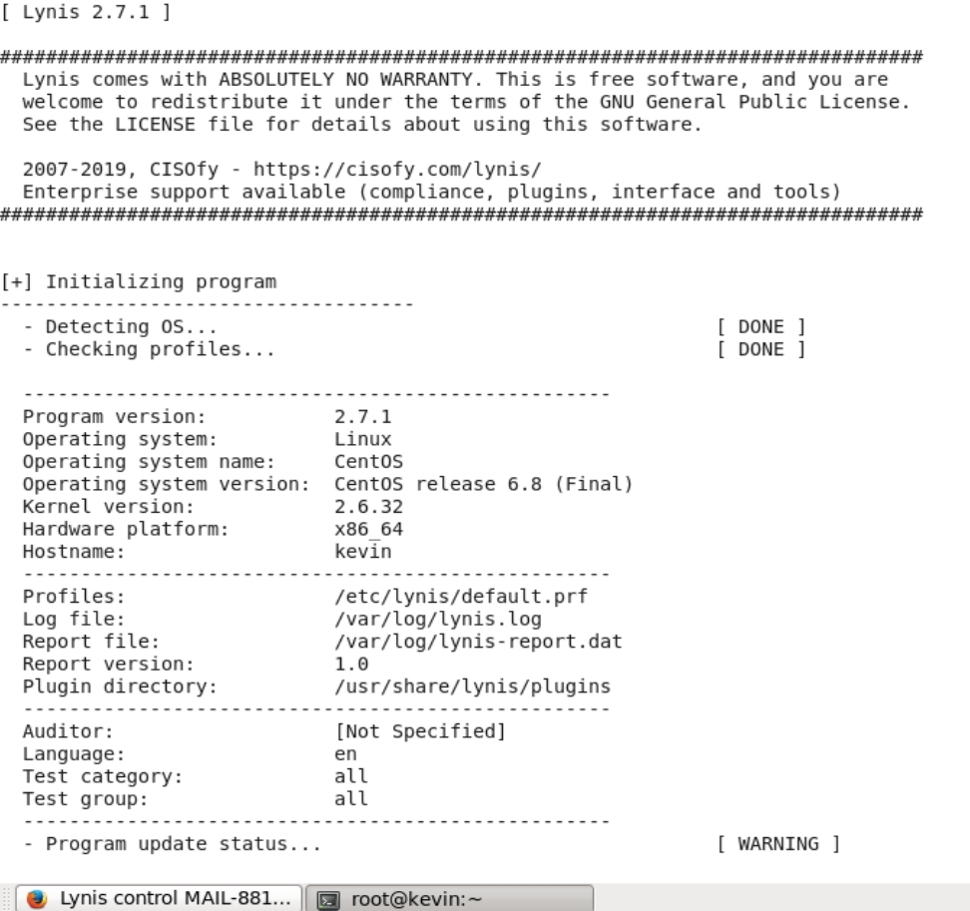

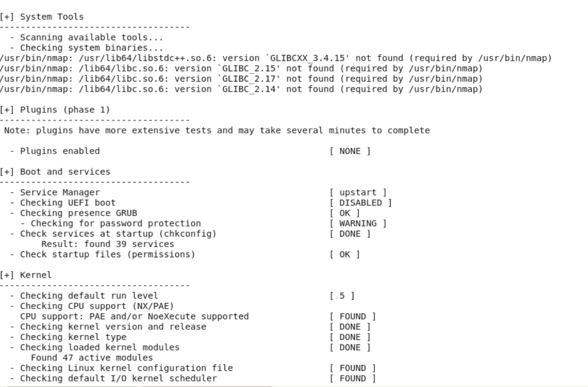

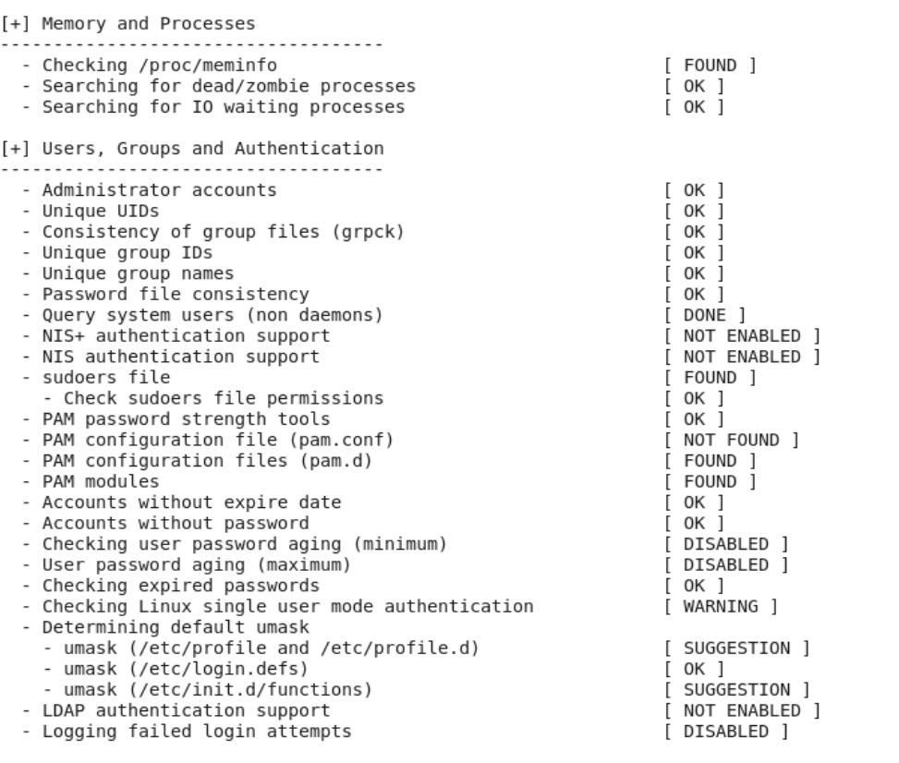

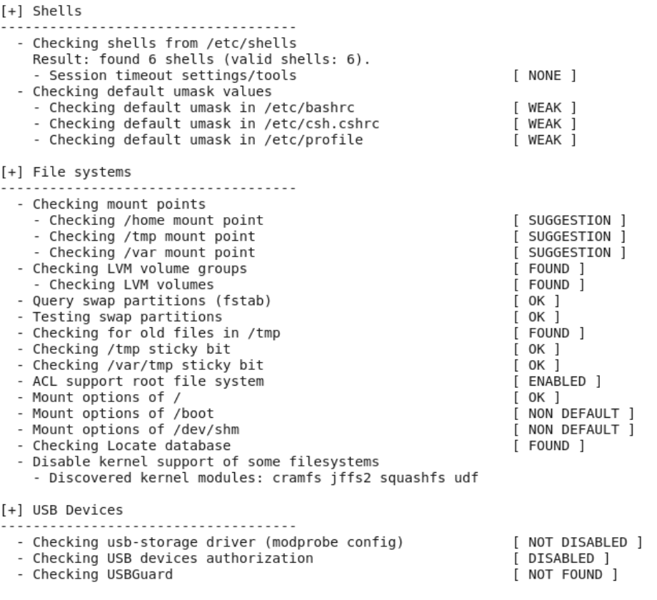

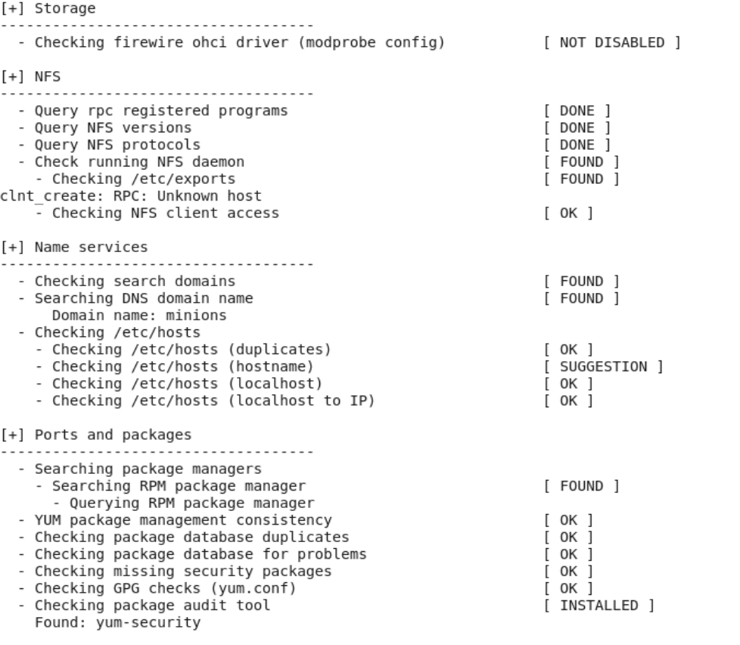

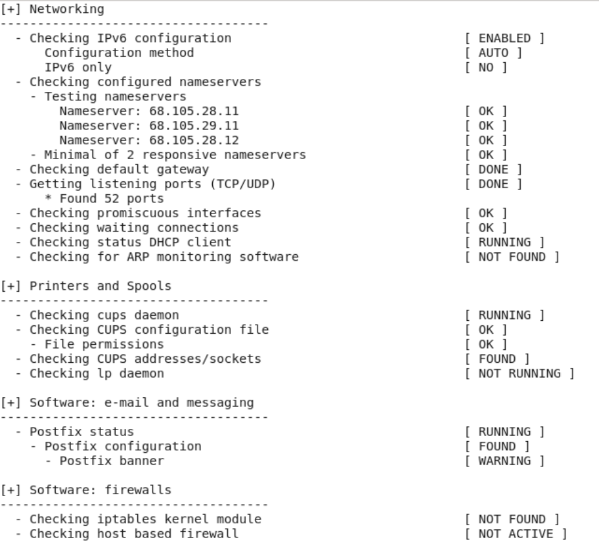

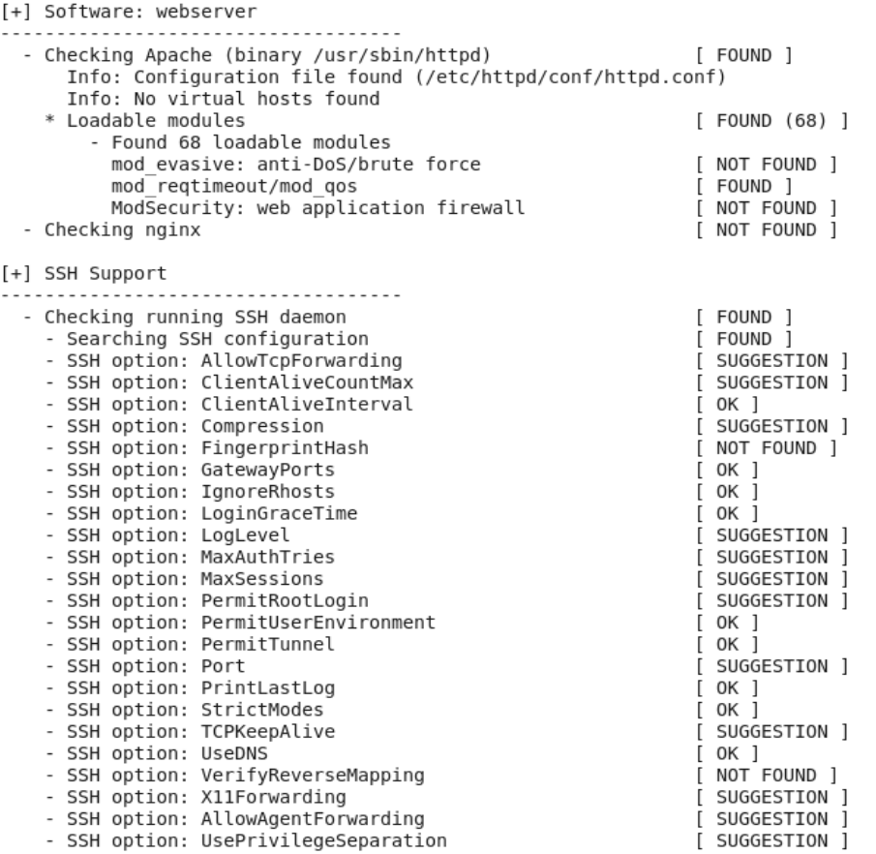

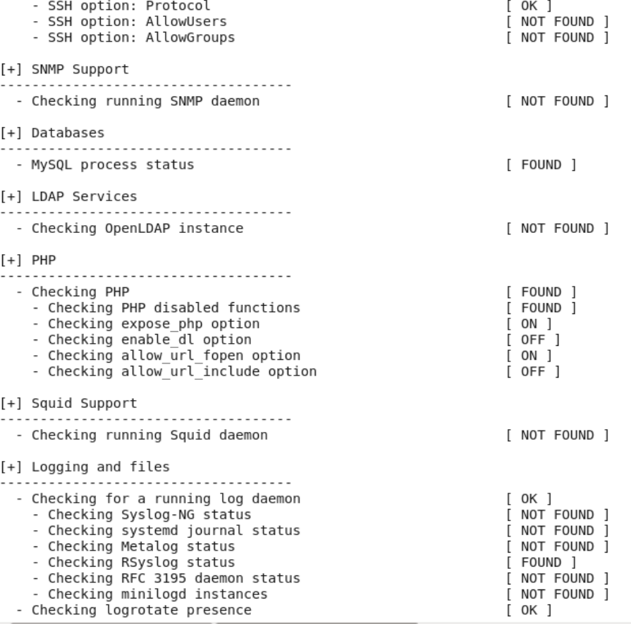

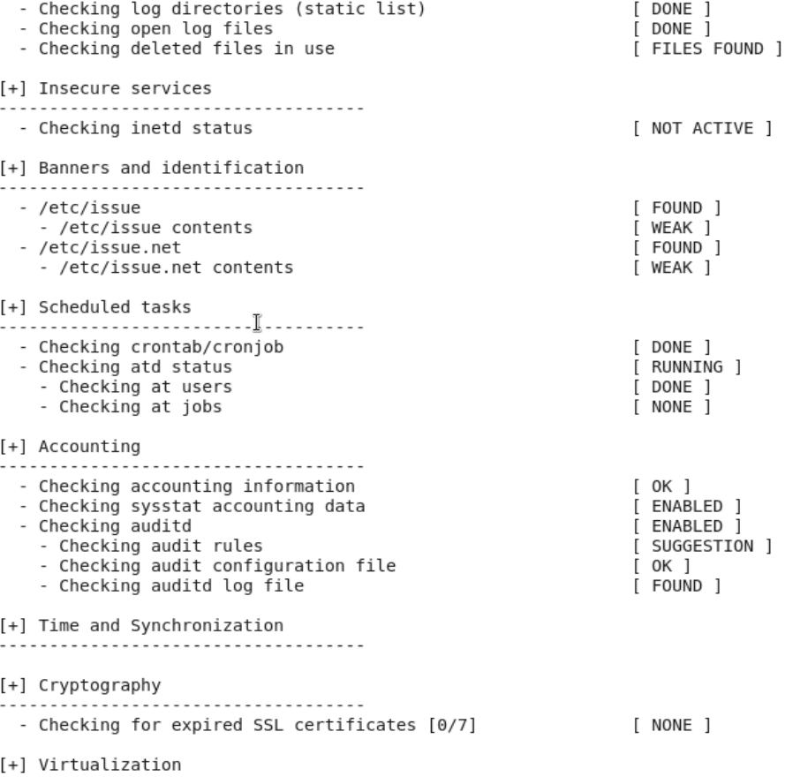

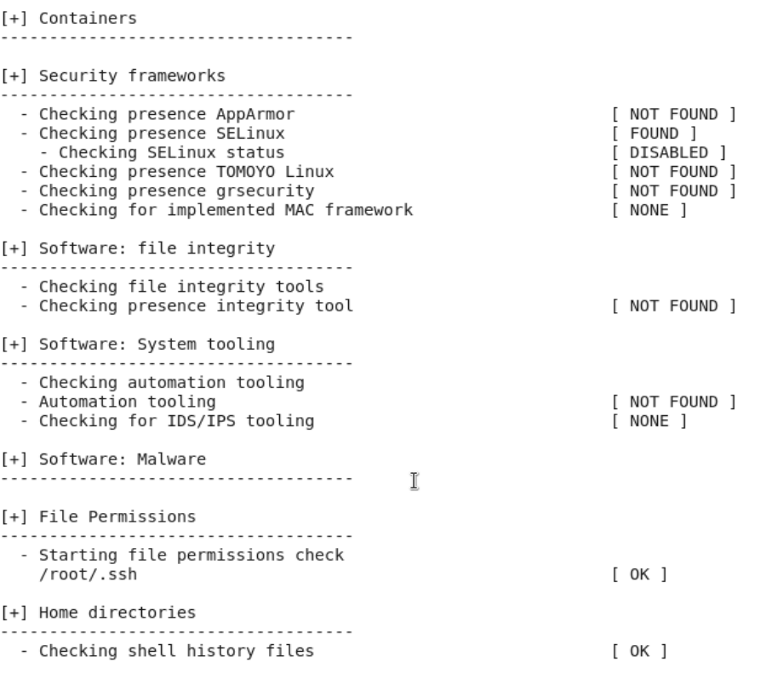

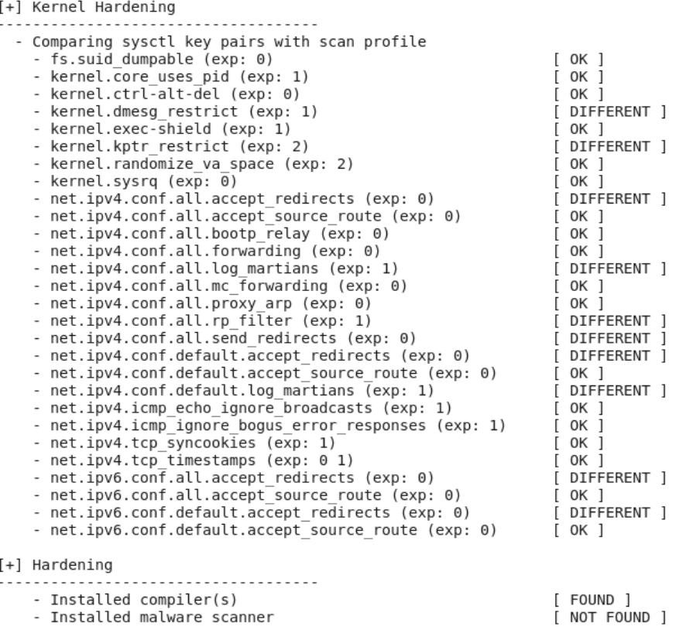

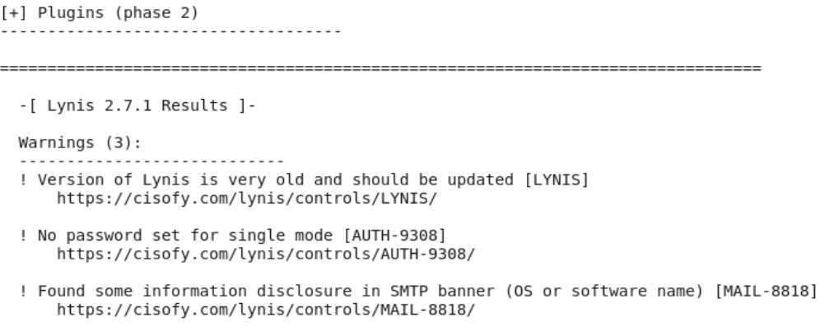

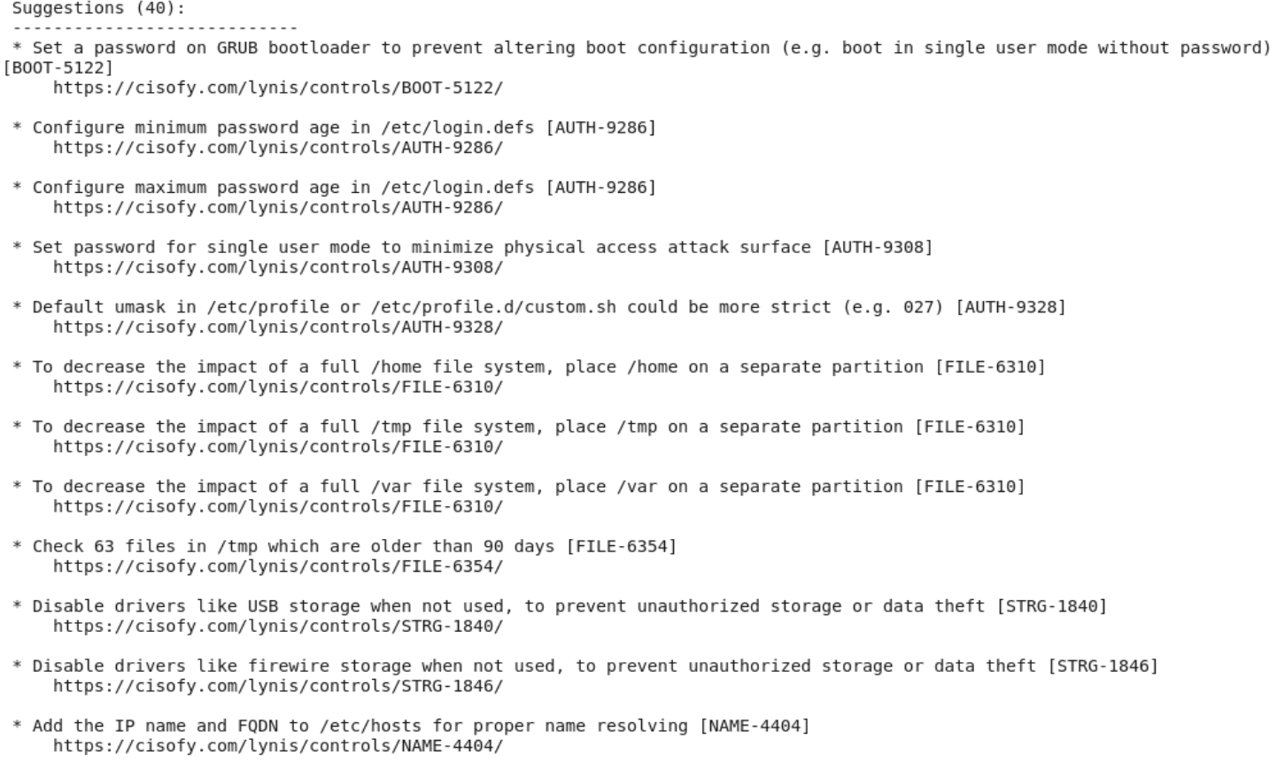

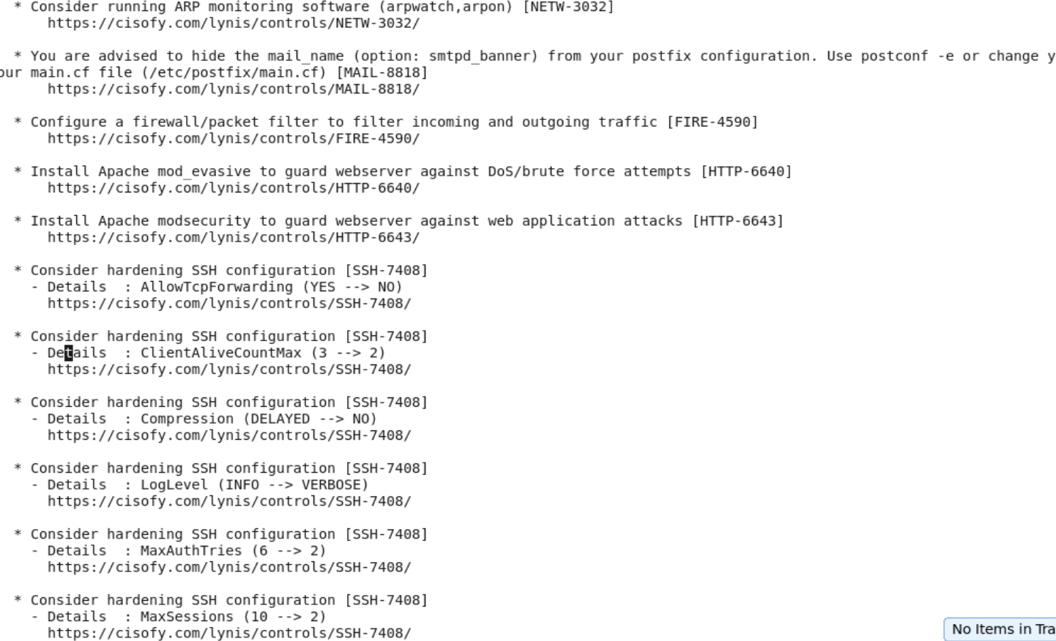

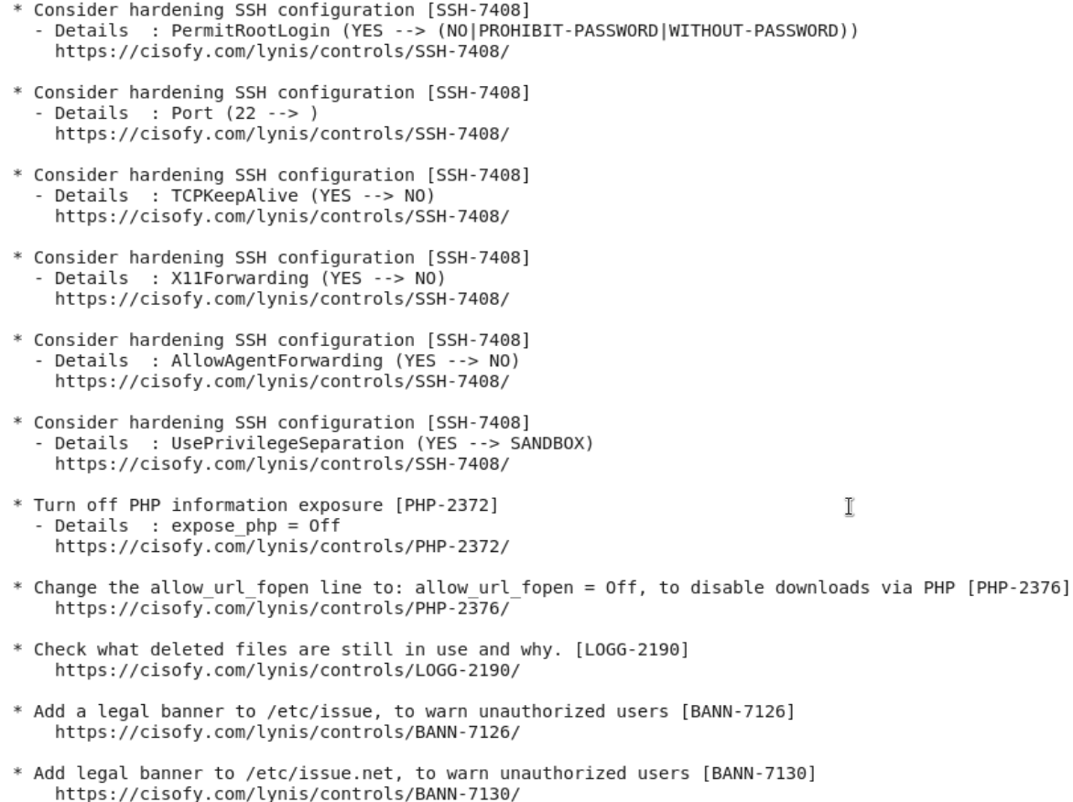

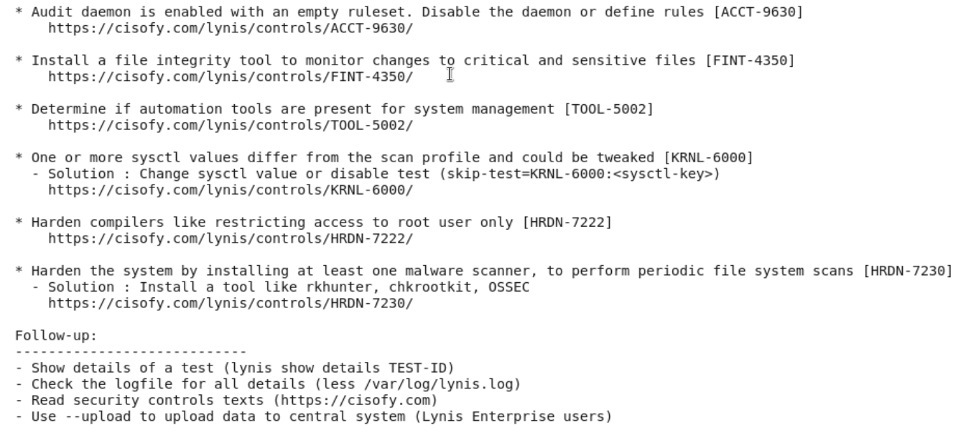

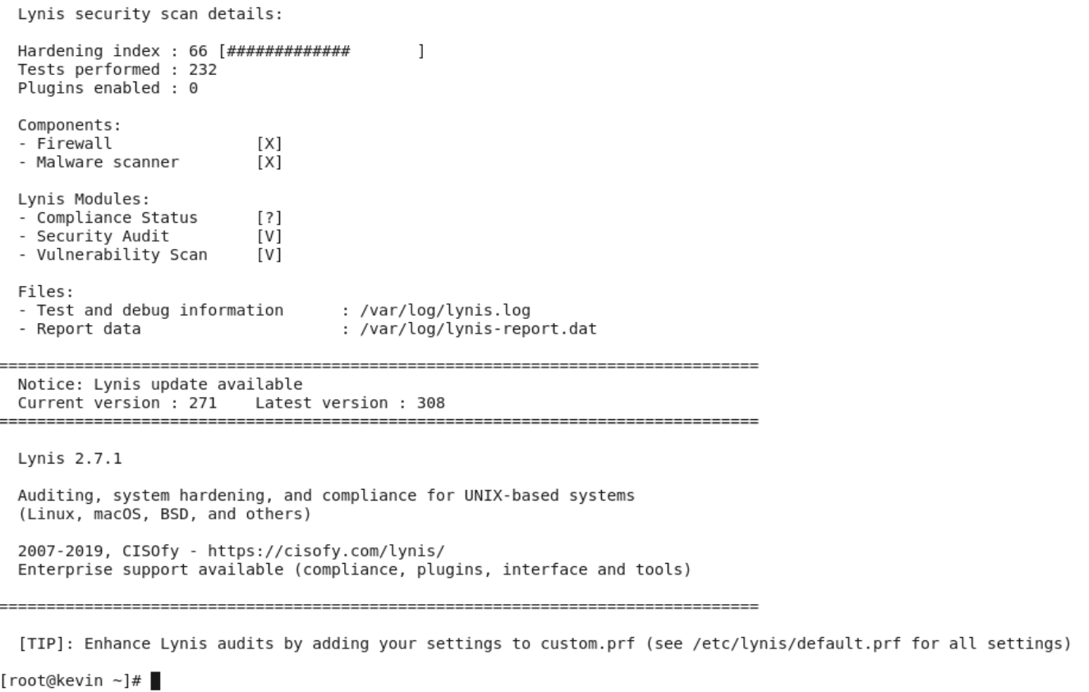

**References**

**11 Tools to Scan Linux Server for Security Flaws and Malware**

<https://geekflare.com/linux-security-scanner/>

**Lynis Installation**

<https://packages.cisofy.com/community/#centos-rhel>

**Basic_CentOS_6_Firewall_Configuration**

<https://www.techotopia.com/index.php/Basic_CentOS_6_Firewall_Configuration#Configuring_a_Basic_CentOS_6_Firewall>

**ICMP Filtering**

<https://john.albin.net/essential-icmp#:~:text=The%20only%20essential%20ICMP%20traffic,optional%20or%20should%20be%20blocked.&text=Notes%3A,OUT%20and%20type%200%20IN>.

**PHP Expose**

<https://beaglesecurity.com/blog/vulnerability/expose-php-is-on.html#:~:text=The%20expose_php%20setting%20is%20used,running%20on%20the%20application's%20server>.

**Ensure SSH AllowTcpForwarding is disabled**

<https://www.tenable.com/audits/items/CIS_Distribution_Independent_Linux_Workstation_L2_v2.0.0.audit:442b5a19a23bed7f8ac3fff5a9c41c01>